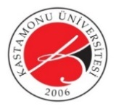 | KASTAMONU ÜNİVERSİTESİ  İNSAN VE TOPLUM BİLİMLERİ FAKÜLTESİ | 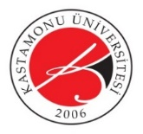
UNVAN - ÖĞRETİM ELEMANI …………….. | HAFTALIK DERS PROGRAMI  WEEKLY COURSE SCHEDULE | 2022-2023 GÜZ

DERS SAATLERİ  Course Time |  | PAZARTESİ  Monday | SALI  Tuesday | ÇARŞAMBA  Wednesday | PERŞEMBE  Thursday | CUMA  Friday
1 | 08:30-09:15
2 | 09:30-10:15
3 | 10:30-11:15
4 | 11:30-12:15
5 | 12:30-13:15
6 | 13:30-14:15
7 | 14:30-15:15
8 | 15:30-16:15
9 | 16:30-17:15
10 | 17:30-18:15
12 | 18:25-19:10
13 | 19:20-20:05
14 | 20:15-21:00
15 | 21:10-21:55
16 | 22:05-22:50
17 | 23:00-23:45

